Weekly Task Report
Geo Learn
11/5/19


Mentor: Fabio Santos
Sponser: Dr. Chris Doughty
Team members: Samuel Prasse (lead), Kaitlyn Grubb,
Tyler Pehringer, Joshus Tenakhongva

 | Weekly Team Task Report | #7

Team: GeoLearn |  |  |  |  |  | Date: 11/6/19
Project Title: Improving elementary education with custom online enironmental science lectures

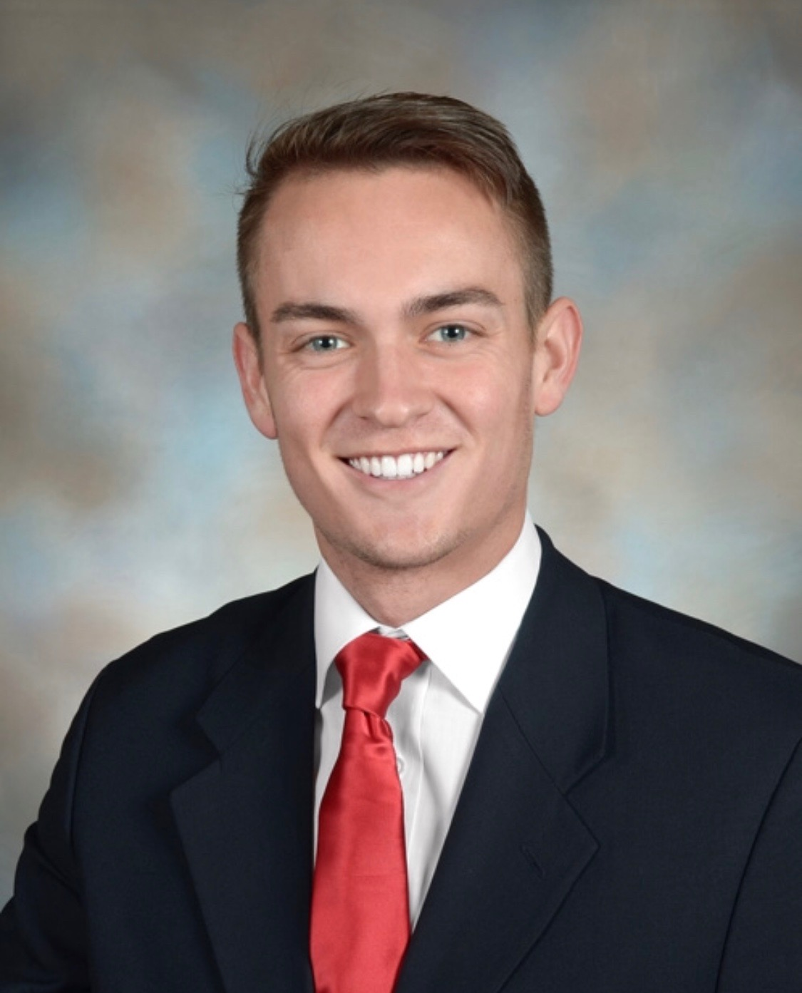 | Samuel Prassse  Present  On-time | 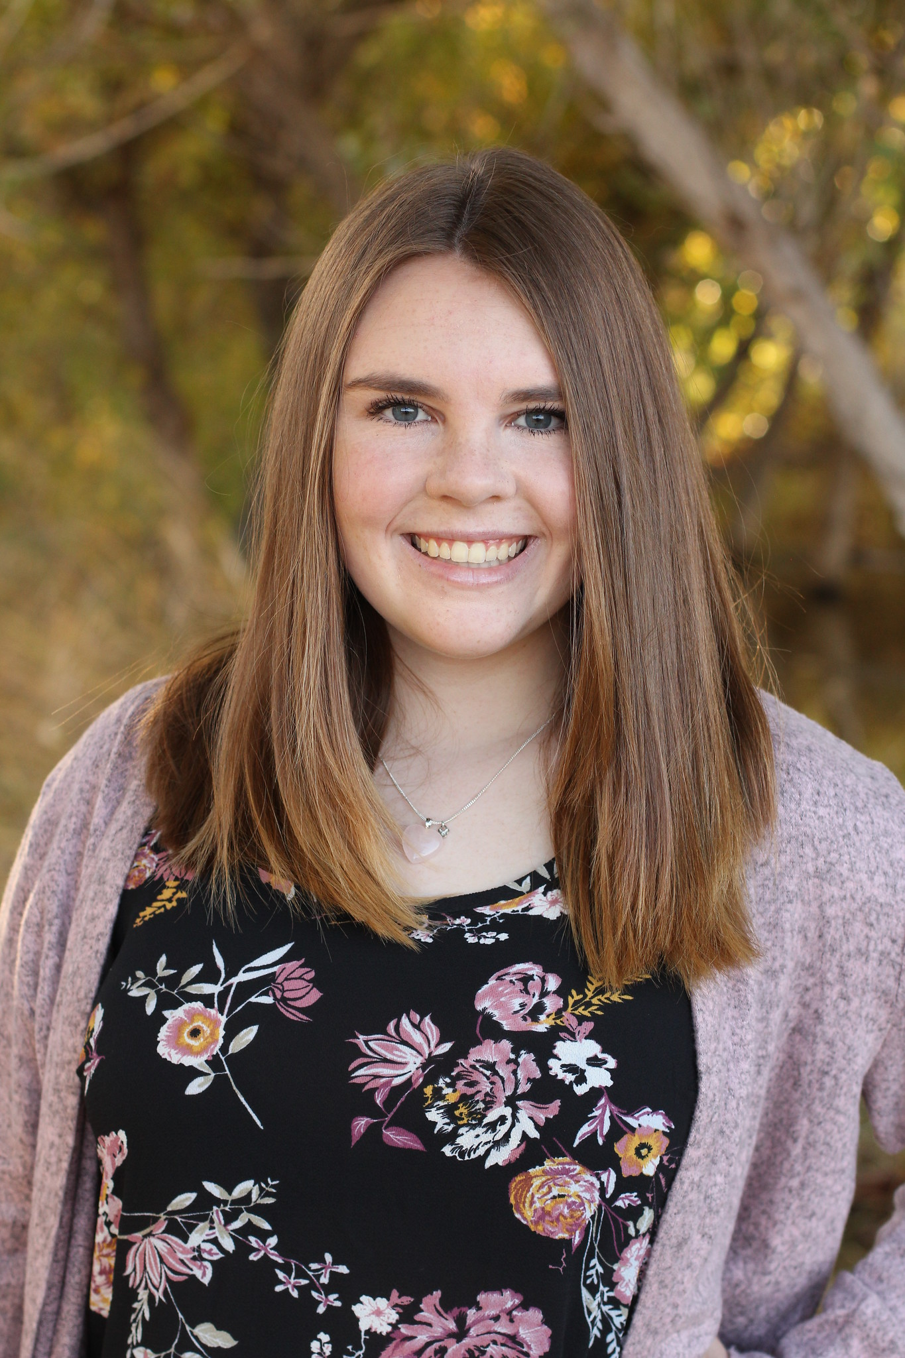 | Kaitlyn Grubb  Present  On-time | 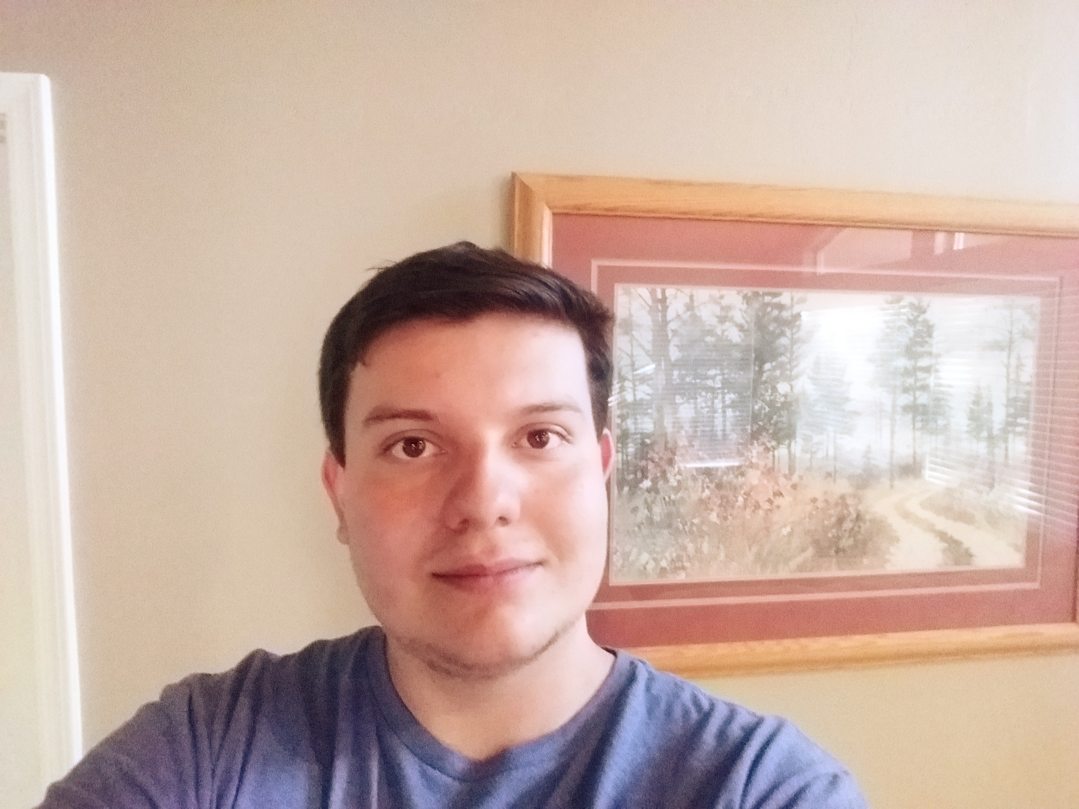 | Tyler Pehringer  Present  On-time |  | 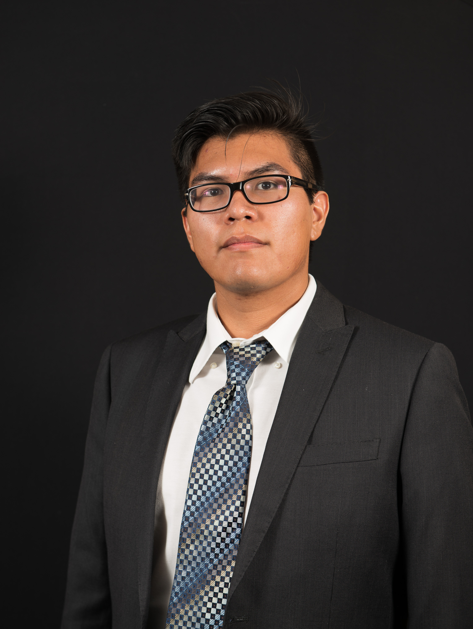 | Joshus Tenakhongva  Present  On-time

Recent Meetings:
- General Team Meeting
- Sponsor Meeting

TASKS COMPLETED since last meeting:
Task Title: Technological Feasibility Final Copy | Task Initiation: 11/4 | Orig. Due Date: 11/8 | Status: Completed
Who (%): Joshus (25%), Kaitlyn (25%), Tyler (25%), Samuel (25%)
Description: Reviewed the changes discussed in last week’s meeting and implemented them into the document.
Expected Outcome: To have a more readable and well-flowing document that iterates our point well.

This week’s Tasks: Work plan for coming week
Task Title: Requirements Specification | Task Initiation: 10/30 | Orig. Due Date: 11/22 | Status: In Progress
Who (%): Joshus (25%), Kaitlyn (25%), Tyler (25%), Samuel (25%)
Description: The requirements specification is a description of our project’s requiremtnts, both functional and non-functional, and forms the contractural basis for the expectations to be fulfilled by the development team.
Expected Outcome: Create a document outlining the requirements that the team will stick to when developing our project.

Task Title: 3 min Team Update | Task Initiation: 10/30 | Orig. Due Date: 11/8 | Status: In Progress
Who (%): Joshus (25%), Kaitlyn (25%), Tyler (25%), Samuel (25%)
Description: Present our current status to the class during dedicated class time. This will include our tech feasibility document contents (very short overview) and our progress on our requirements document. Also will outline any important items as discussed in the prior weeks meetings with our mentor and sponsor.
Expected Outcome: A short but very informative presentation on our progress from the past month since our last presentation.

Task Title: Peer Eval | Task Initiation: 11/4 | Orig. Due Date: 11/8 | Status: In Progress
Who (%): Team (100%)
Description: Each team member will fill out a peer eval and send it to Fabio by November 8th.
Expected Outcome: An accurate representation of effort and time invested by individual team members as graded by the other 3 team members.

Upcoming Tasks: Planning
Task Title: Design Review Presentations | Who (%): Team (100%) | Rough Due Date: 11/22
Description: 10 – 12 minute presentation on our projects design.

Other Problems / Other Issues:
- Where are we hosting our web app?

